OCEANA COUNTY 4-H MARKET LIVESTOCK
EDUCATIONAL NOTEBOOK/RECORD

LAMB PROJECT - 2023

AGES 12-14
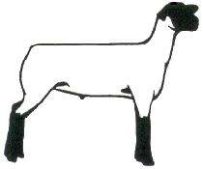
As a member of the 4-H Market Livestock Lamb project you are required to submit your records as part of an educational project notebook in order to sell your animal at the 4-H Market Livestock Sale. This notebook must be shown to the Oceana County 4-H Market Livestock Committee's Weighmaster at the time of weigh-in and then entered by you in the Educational Notebook Division of the Oceana County Fair on Entry Day.

AGE: ________

Remember: The age you enter depends on how old you are or will be on Jan. 1, 2023

Number of years in project: ________

Use this sheet as the first page of your project record book. Fill it out completely.
Please print or type neatly.

NAME_______________________________________________________________________

4-H CLUB_____________________________________________________________________

BREED________________________________LAMB’S NAME__________________________

DATE OF BIRTH___________________ DATE RECORD STARTED_____________________

LOCATION WHERE ANIMAL IS RAISED __________________________________________



JUDGE’S SCORE/COMMENT SHEET

(PLEASE DO NOT REMOVE, PLACE THIS SHEET IN SHEET PROTECTOR OR GLUE TO COVER). This sheet must be kept free for the judge to write their comments.

This sheet should help each 4-H’er understand their ribbon placing.

A. Specific educational value or worth

___ All questions were answered completely

___ All calculations were correct

___ Calculations were incorrect

___ Questions were not completely answered

___ Questions were not answered (missed questions)

B. Notebook contains all project records

___ Notebook contained all project records and were fully completed

___ Notebook contained additional project related information (research

materials etc.)

___ Project records were incomplete

___There was no additional project related information

C. Accuracy, neatness and general appearance

___Notebook was neat in appearance (typed/hand printed)

___Notebook pages were clean and stain free

___Notebook pages were in order and complete

___Notebook pages were out of order and missing pages

___Notebook was difficult to read and messy

__Notebook had wrinkled and stained pages

Other Comments: ______________________________________________________

____________________________________________________________

____________________________________________________________

4-H MARKET LIVESTOCK LAMB NOTEBOOK- 2023
AGES 12-14

TABLE OF CONTENTS

Please keep your notebook in Table of Contents order.

- GENERAL GUIDELINE INFORMATION

- JOURNAL OF CARE

- PROJECT INFORMATION

- SPECIFIC EDUCATIONAL PROJECT KNOWLEDGE
  - Breed Scramble
  - Marketing
  - Lamb Parts Identification
  - Fitting & Showing
  - Wholesale Cuts
  - Sheep By-Products

- MY PROJECT INFORMATION
a) Your Project
b) 4-H Info & Activities

- BUYERS NAMES

- PICTURES OF YOUR PROJECT (1 page)

- NON-CLUB/CLUB POINTS SHEETS

APPENDIXES (OPTIONAL):

- PICTURES OF YOUR PROJECT (additional pictures)
- FEED INFORMATION (example: feed labels etc.)
- ADDITIONAL INFORMATION ABOUT YOUR PROJECT
  - Information you found in reference materials
  - Information you located off the internet
  - Information gathered from your feed representative
  - Any other information
* Include notes as to why you researched this information and found it
Valuable, link it to your project if possible.

Note: Reference materials used for the specific project knowledge include:

a. 4-H Market Livestock Lamb Project Rules
b. Your Sheep – A Kid’s Guide to Raising and Showing
c. 4-H Skills for Life Animal Science Series – Lambs 1, 2 & 3
(All swine leaders have a copy and copy available on check-out system at MSU Extension)
d. Kansas State 4-H Online
e. Lamb Resource Book (The Ohio State University 4-H)

2023- Lamb Record Book (12-14) Page 1

This record is part of your 4-H Market Lamb Project work. By keeping records up to date you will be able to see how much progress you make as you set goals and work to accomplish them. Write neatly and clearly. Feel free to add extra pages.

PROJECT PICTURES

Pictures are a required part of this notebook. Taking pictures of your project animal throughout the project will indicate how your animal has grown and developed. Add pictures to your notebook on a separate piece of paper.

SCORING CRITERIA

The following breakdown will be used during the judging process of all market livestock notebooks.

A. Specific educational value or worth 30%

B. Creative way of showing what has been learned 10%

C. Notebook contains all project records 50%

D. Accuracy, neatness and general appearance 10%

The Oceana County 4-H Market Livestock Committee encourages 4-H Leader and parent assistance with your project and project notebook. If you should have any questions, please contact the MSU Extension Office.

I, ____________________________ assisted ________________________ in
Parent/Leader/Adult Name 4-Her’s Name
understanding the questions and writing the answers. All answers are those of the 4-Her.

____________________________________
Signature of person helping with notebook
If written help was needed

2023- Lamb Record Book (12-14) Page 2

JOURNAL OF ANIMAL CARE

The 4-H Market Livestock Committee is requiring all 4-H Market Livestock members to complete the “Journal of Care”, so the judge may see the time, effort and care you have put into learning about your animal.

** It will be assumed that you walked & fed your animal, but what additional things have you done such as washed, clipped, trimmed, foot care, health practices, medicines, general maintenance (cleaning living area & feed pans), halter breaking, training, had vaccinated, etc. **

APRIL:

MAY:

JUNE:

2023- Lamb Record Book (12-14) Page 3

JOURNAL OF ANIMAL CARE
(cont.)
JULY:

AUGUST:

If not housed at your home, have the property owner sign. If housed at your home, please have your parent sign.

I,___________________________________,do attest and certify that this 4-Her has
(property owner name (please print), if parent -please print
cared for this animal in a responsible manner while housed on my property. I also understand that integrity and responsibility are important to this 4-H experience.

__________________________________ ______________
Signature of Property Owner or Parent Date
If housed on own property

2023- Lamb Record Book (12-14) Page 4

PROJECT INFORMATION

The start of the project will be the date the 4-Her placed the animal on feed, not any later than June 1st of the current year. The end of the project will be weigh-in day at the Fair.

Project Start Date June 1, 2023__________ Project End Date ________________ Fair Haul In

What month was your lamb born? __________________________

Please complete the following chart about your project.

4-H Ear Tag  Number | Breed | Gender | Date of Purchase | Price or value | Estimated Starting Weight | Ending/FinalWeight  (FW) | Total Pounds Gained
Note: Total pounds gained = ending weight – starting weight

MONTHLY FEED RECORD & EXPENSES

Month | Type of feed used-  (grain, roughage, etc.) | Supplements  (if any used) | Amount  (indicate lbs., bales etc.) | Cost of feed used for the month
April
May

2023- Lamb Record Book (12-14) Page 5

MONTHLY FEED RECORD & EXPENSES (cont.)

Month | Type of feed used-  (grain, roughage, etc.) | Supplements  (if any used) | Amount  (indicate lbs., bales etc.) | Cost of feed used for the month
June
July

August
Column Totals

Total Feed Costs for Project $________________

2023- Lamb Record Book (12-14) Page 6

EXPENSES OTHER THAN FEED

The 4-H Market Livestock Committee would like you to keep a running list of all of your expenses -- veterinary charges, bedding, insecticides, trucking, insurance, interest paid on money borrowed, housing etc. Even if your parents pay for these items, figure out how much your animal needs and or uses as this is an expense of YOUR project.

 | Vet  Charges | Bedding | Insecticides | Equipment | Trucking | Housing/Rent | Shearing or  Clipping | Advertising/  Marketing | Miscellaneous (specify)  Include 4-H enrollment | Buyer Recognition | MONTHLY TOTAL
APR
MAY
JUNE
JULY
AUG
TOTALS

2023- Lamb Record Book (12-14) Page 7

PROJECT EFFICIENCY INFORMATION

(using figures from page 4,5 and 6)

Value of Animal at Time of Purchase = ___________

__________________ ÷ ______________ = __________________________
Total lbs. of Gain Days on Feed Average Daily Rate of Gain
(from page 4)

_______________ ÷ __________________ = __________________________
Total Feed Cost Total lbs. of gain Feed Cost per lbs. of Gain

______________________÷__________________=___________________________
Total lbs. of feed fed Total lbs. of gain Lbs. of Feed Fed per lb. of Gain

_________________ + ______________ + ______________ = ______________ (TE)
Total Feed Expense Cost of Animal Other Expenses Total Project Expense

Lambs are sold by the pound at a Large Animal Sale Auction. Find out what bid price (per lb.) you need to get at the Large Market auction to breakeven (BE) on your market lamb project.

__________________÷____________________= ____________________________
Total Expenses (TE) Final Weight (FW) Break Even Price (BE)
(or total cost per lb. to raise your animal)

What is the current selling price of lamb (per lb.)? _____________________________

Where did you find the current selling price? ________________________________
(if your source was a person, ask them where they got this information)

Would you have been able to make a profit selling on the open market? __________

Why or why not? _______________________________________________________

_____________________________________________________________________

_____________________________________________________________________

2023- Lamb Record Book (12-14) Page 8

PROJECT KNOWLEDGE

BREED MATCHUP -
(unscramble the breeds & then draw a line to the correct description)

_____________________ White faced and legs. English breed. E T R D O S Small to medium in size. Polled with
long wool.

_____________________ Large framed, white faced, dual-purpose O U B A C L M I breed Originating in the US. Produce heavy lambs & heavy dense fleece. Polled.

_____________________ Large framed, fast growing, black face, M O N E Y R and legs, polled. Has the most number of purebred registrations in the US. Known for its meatiness & high carcass quality.
_____________________ (Horned or polled) white faced, meat A M P R E I H S H breed known for out-of-season breeding.

_____________________ Large framed, meat breed with wool cap F K F O U S L and wool on legs. Partially closed face. Black face & legs. Polled.

_____________________ Medium to large in size, has a dark P P A O Y L Y brown to grey face and is polled. They have a wool cap, and wool on the ears & legs. Good milkers with a fast growth rate.

_____________________ Developed in the US at the Sheep D R O O X F Experiment Station. This breed is medium-sized, white-faced, prolific and breeds out of season.

2023- Lamb Record Book (12-14) Page 9

MARKETING

One of the most important parts of any market animal project is marketing. This includes writing a letter, talking to buyers and making sure you thank your previous buyers in a timely fashion.

- What did you do to market your animal this year?
- If you have participated in a market livestock project before what did you do differently in marketing your animal this year?

______________________________________________________________________

______________________________________________________________________

______________________________________________________________________

______________________________________________________________________

MARKETING TIPS & TRICKS

Answer True or False to the statements below on good marketing practices to use when attracting potential buyers.

It is best to seek potential buyers the week before the auction. T F

You should be polite and mindful of potential buyer’s time when
asking them to be a potential buyer. T F

Providing information on the breed of your animal to potential
buyers can be helpful. T F

Arriving at the potential buyer’s place of business at the busiest
time of the day is a perfect time to ask them to be potential buyer. T F

Sending an introduction letter or note to potential buyers is a good
way to make the first contact with potential buyers. T F

Being timely in following up with a thank you to the buyer is not
necessary. They will see the ad in the newspaper T F

Noticing the buyer’s that purchased the previous year and the
animals they purchased can help in determining who to contact. T F

You should stay in touch with potential buyers throughout the
duration of your project. T F

2023- Lamb Record Book (12-14) Page 10

MARKETING TIPS & TRICKS (cont.)

It is best to have your parents approach potential buyers on your
behalf, they are the adults. T F

Thanking a buyer for just coming to the auction is not necessary T F

A handwritten thank you note on a scrap piece of paper is an
excellent way to thank your buyer. T F

Thanking the buyer with a small appreciation gift is a good
Idea. T F

Visiting buyers who previously purchased your animals is not
worth your time each year. T F

Presenting yourself in a business manner when approaching
a buyer to be a potential buyer is a good idea. T F

2023- Lamb Record Book (12-14) Page 11

PARTS OF THE LAMB IDENTIFICATION
Ages 12-14 identify 18 parts
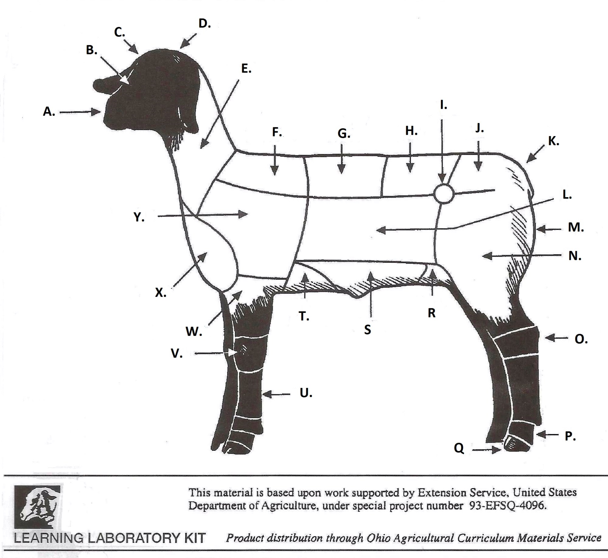
___ Back or Rack ___ Belly ____ Breast or Brisket

___ Cannon ___ Dock ____ Face

___ Fore Arm ___ Fore Flank ____ Forehead

___ Hips ___ Hock ____ Hoof

___ Knee ___ Leg ____ Loin

___ Middle ___ Muzzle ____ Neck

___ Pastern ___ Poll ____ Rear Flank

___ Rump ___ Shoulder ___ Top Shoulder

___ Twist

2023- Lamb Record Book (12-14) Page 12

FITTING & SHOWING THE MARKET LAMB
Answer True or False for each statement

Proper fitting and grooming of a lamb can be done on show day. T F

When breaking a lamb to stand, never let it jerk loose and run
away from you. T F

Daily walks will help your lamb show better. T F

To get your lamb to move, you can pull up on the dock or
apply pressure behind the ears. T F

To lead your lamb, place one hand under the jaw, keep the head
up and alert and put the other hand on the dock or behind the ears. T F

It is ok to hold your lamb by its fleece. T F

Practicing showmanship is not necessary until the actual day of
the showmanship classes. T F

Slick shearing a lamb can be done 1 week prior to fair. T F

It is best of use a mild soap or detergent to wash your lamb. T F

Apply a lot of soap to get a good lather to scrub out all the dirt
and dung from the lamb’s fleece. T F

To train your lamb’s wool it is important to always brush in the
same direction. T F

Curry combs are used to remove excess water and dirt from your
lamb’s fleece. T F

Bring your lamb into the show ring quickly as to not delay the
class getting started. T F

It is fine to kneel on the ground once you have your lamb set up
in the show ring. T F

Always keep your animal between you and judge during the show. T F

2023- Lamb Record Book (12-14) Page 13

KNOWING YOUR LAMB-PROJECT KNOWLEDGE

WHOLESALE CUTS

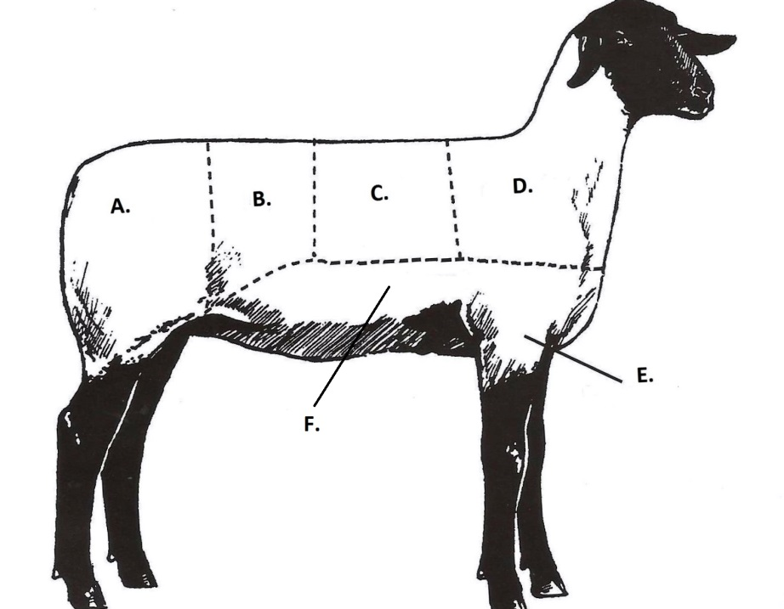

UNSCRAMBLE THE WHOLESALE CUT (WRITE THE WORD) AND MATCH IT TO THE CORRECT LETTER ON THE PICTURE

WORD LETTER

_______________ HOLRSUDE _____

_______________ SHFREOAKN _____

________________ NIOL _____

________________ GEL _____

________________ TBESRA _____

_________________ARCK _____

UNSCRAMBLE THE WHOLESALE CUT (WRITE THE WORD) AND MATCH IT TO THE CORRECT LETTER ON THE PICTURE

WORD LETTER

_______________ HOLRSUDE _____

_______________ SHFREOAKN _____

________________ NIOL _____

________________ GEL _____

________________ TBESRA _____

_________________ARCK _____

2023- Lamb Record Book (12-14) Page 14

SHEEP BY-PRODUCTS WORD SEARCH
Find the sheep by-products in the word search

F | I | L | M | A | B | S | H | O | E | S
C | E | D | P | L | Y | W | O | O | D | N
M | A | R | G | A | R | I | N | E | E | O
C | L | O | T | H | E | S | E | C | U | T
E | F | H | G | I | E | F | H | H | S | T
D | I | C | E | L | L | I | V | E | R | U
I | J | U | D | A | D | I | C | E | K | B
L | L | N | M | P | R | M | Z | S | N | O
G | A | I | A | P | Q | T | R | E | S | T
C | N | O | M | A | T | C | H | U | R | V
A | S | E | A | T | C | O | V | E | R | S

WORD BANK

Animal Feeds Buttons Candles Cheese Clothes Dice
Fertilizer Film Glue Heart Liver
Margarine Match Plywood Seat Cover Shoes
Soap Suede

2023- Lamb Notebook (12-14) Page 15

your project

1. What did you learn that you did not know, about your project?

______________________________________________________________________

______________________________________________________________________

_____________________________________________________________________

_____________________________________________________________________

2. What is the best feature(s) of your market lamb this year?

______________________________________________________________________

______________________________________________________________________

_____________________________________________________________________

_____________________________________________________________________

3. What are 2 marketable features of your animal that you would share with potential buyers?

______________________________________________________________________

______________________________________________________________________

_____________________________________________________________________

_____________________________________________________________________

4. Will you participate in a market lamb project again? ___________________________

Why or why not? ______________________________________________________

______________________________________________________________________

______________________________________________________________________

2023- Lamb Notebook (12-14) Page 16

4-H INFORMATION
The 4-H Pledge

I pledge…..

___________________________________________________________________________________,

___________________________________________________________________________________,

___________________________________________________________________________________,

___________________________________________________________________________________,

___________________________________________________________________________________,

___________________________________________________________________________________.

The 4-H MOTTO:______________________________________________________

List 1 way that you helped or taught others this year:

_____________________________________________________________________

_____________________________________________________________________

________________________________________________________________________________________________________

________________________________________________________________________________________________________

_________________________________________________________________________________________________________

2023- Lamb Notebook (12-14) Page 17

4-H ACTIVITIES

Number of club meetings held: ____________ Number I attended: ____________

List any club activities in which you have:
        - Participated in
        - Responsibilities which you have assumed

(for example: Community Service Events, workshops, judging contests, clinics, offices held, parades representing 4-H etc. If none, write none)

Activity | Date | Location | Placing, Position or Comments

POTENTIAL BUYERS NAMES

As part of your 4-H Market Livestock Project, you must personally contact at least five potential buyers before the Oceana County Fair. You are encouraged to seek two new buyers that have not been asked or submitted before. You also must have at least three different buyers than those of your siblings in the market livestock project. Please confirm with your buyers their accurate mailing address (example: post office box vs. a street address). The information on page 18 must be completed and taken to the Oceana County MSU Extension Office on or before the due date where it will be copied and used to send out letters to your potential buyers. This page will remain in your notebooks. This is a Market Livestock Committee rule. Failure to comply will result in not being able to sell your animal in the 4-H Market Livestock Sale.

2023-Lamb Record Book (12-14) Stamp _______________
PAGE 18 Staff _______________

4-H MARKET LIVESTOCK POTENTIAL BUYER’S LIST
SWINE PROJECT (AGES 15-19)

Name______________________________ Club_________________________
Please print business names and complete addresses clearly.

  - Contact Name ____________________________________________________

Business Name ____________________________________________________

Mailing Address _________________________City_________________Zip_____

Phone _______________________ After Hours Phone______________________
Mailing Preference (Please Check One): Email ____ Postal Delivery ____

Email ____________________________________________________________

Signature__________________________________________________________

2. Contact Name ____________________________________________________

Business Name ____________________________________________________

Mailing Address _________________________City_________________Zip_____

Phone _______________________ After Hours Phone______________________
Mailing Preference (Please Check One): Email ____ Postal Delivery ____

Email ____________________________________________________________

Signature__________________________________________________________

3. Contact Name ____________________________________________________

Business Name ____________________________________________________

Mailing Address _________________________City_________________Zip_____

Phone _______________________ After Hours Phone______________________
Mailing Preference (Please Check One): Email ____ Postal Delivery ____

Email ____________________________________________________________

Signature__________________________________________________________

(Must be stamped by the MSU Extension Office)

2023-Lamb Record Book (12-14) Stamp _______________
PAGE 19 Staff _______________

If you would like to contact additional buyers you can use this page. If not please throw this page out.

Contact Name ____________________________________________________

Business Name ____________________________________________________

Mailing Address _________________________City_________________Zip_____

Phone _______________________ After Hours Phone______________________
Mailing Preference (Please Check One): Email ____ Postal Delivery ____

Email ____________________________________________________________

Signature__________________________________________________________

Contact Name ____________________________________________________

Business Name ____________________________________________________

Mailing Address _________________________City_________________Zip_____

Phone _______________________ After Hours Phone______________________
Mailing Preference (Please Check One): Email ____ Postal Delivery ____

Email ____________________________________________________________

Signature__________________________________________________________

Contact Name ____________________________________________________

Business Name ____________________________________________________

Mailing Address _________________________City_________________Zip_____

Phone _______________________ After Hours Phone______________________
Mailing Preference (Please Check One): Email ____ Postal Delivery ____

Email ____________________________________________________________

Signature__________________________________________________________

2023- Lamb Notebook (12-14) Page 20

YOUR PROJECT PICTURES

(Please use this page for your project pictures. If you have more than 1 page of pictures please use the appendix section to include those pictures).

NON-CLUB POINTS

8 YEARS OLD & UP MUST COMPLETE- MARKET LIVESTOCK ANIMAL ASSOCATION PROJECT ATTENDANCE RECORD
(This must be filled out before presenting for signatures at the office.)
MEETING NAME | LOCATION | DATE | POINTS | SIGNATURE OF LEADER, SUPERINTENDENT OR MSU STAFF

Please note: This form must be included with your record notebook and turned into the weigh master on entry day of the Fair. BEFORE SEEKING SIGNATURES AT MSU EXTENSION – MEETING NAME AND DATE MUST BE COMPLETED You need to accumulate nine (9) points to be allowed to sell your animal. Six (6) of these nine (9) points must come from club meetings. The three (3) non-club points must be earned from attending various 4-H events and activities. See your leader, the MSUE office, or https://www.canr.msu.edu/oceana/oceana_county_4_h/oceana_4_h_market_livestock for a listing of approved nonclub points.

CLUB POINTS
MARKET LIVESTOCK ATTENDANCE RECORD- ALL AGES MUST COMPLETE
(This must be filled out before presenting for signatures at the office.)

MEETING NAME | LOCATION | DATE | POINTS | SIGNATURE OF LEADER, SUPERINTENDENT OR MSU STAFF
Pease note: This form must be included with your record notebook and turned into the weigh master on entry day of the Fair. You need to accumulate nine (9) points to be allowed to sell your animal. Six (6) of these nine (9) points must come from club meetings. The three (3) non-club points must be earned from attending various 4-H events and activities.

